Our products and revenue model
How ANVEXA Generates Revenue
1. Cloud Services
- Cloud migration, infrastructure setup, monitoring and managed support.
- Revenue through implementation fees and recurring support contracts.
2. Cybersecurity Services
- Security assessments, system hardening, access controls and monitoring.
- Revenue through assessments and ongoing security service contracts.
3. AI and Business Automation
- Workflow automation, scheduled reports and business process improvement.
- Revenue through implementation fees, subscriptions and customization.
4. Custom Software Development
- Business dashboards, web applications, mobile applications and integrations.
- Revenue through fixed-scope projects and maintenance contracts.
Our Revenue Streams
- Recurring subscription and support revenue.
- One-time implementation and migration fees.
- Custom development project revenue.
- Additional service and integration fees.

Our client base and revenue reach
Client Profile and Revenue Reach
Illustrative Year 3 client profile
- Active recurring clients: 32.
- Cumulative completed projects: 45+.
- Annual recurring revenue (ARR): ₹90 lakh.
- Average ARR per recurring client: approximately ₹2.81 lakh per year.
- Target sectors: Retail and distribution, IT and software services, logistics and manufacturing, and professional services.
Illustrative Client Distribution
- Retail and distribution: 14 clients.
- IT and software services: 8 clients.
- Logistics and manufacturing: 6 clients.
- Professional services: 4 clients.
Client acquisition strategy
- Direct B2B sales in Pune and Mumbai.
- Referrals and relationships with existing clients.
- Partnerships with IT consultants and technology providers.
- Case studies demonstrating measurable project outcomes.

Why these figures are reasonable within the scenario:
- The 32 clients represent the active recurring-client base at the end of Year 3, not necessarily all clients served over three years.
- The 45+ projects can include multiple projects delivered to the same client.
- ₹90 lakh ARR divided by 32 clients gives ₹2.8125 lakh annually per client on average, or approximately ₹23,438 monthly.

Three-year financial performance
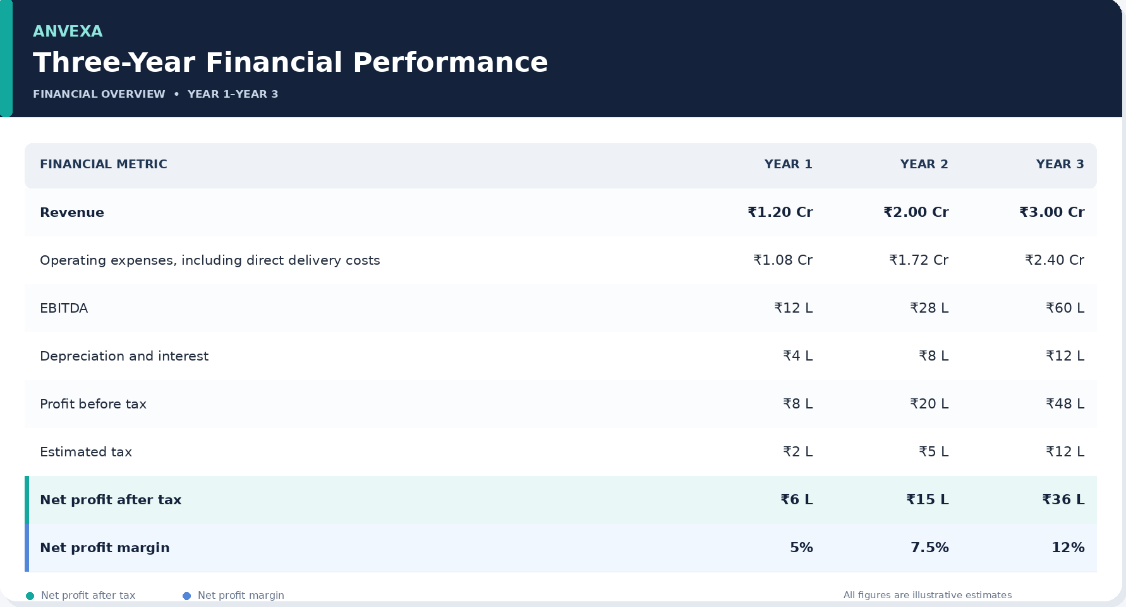
Revenue Growth
- Year 2 revenue growth: 66.7%.
- Year 3 revenue growth: 50%.
- Three-year cumulative revenue: ₹6.20 crore.
Financial Objective
Increase revenue while improving profitability, maintaining cost discipline, and developing a larger recurring-revenue base.
Justification for every number
Figure | Calculation or explanation
Year 1 revenue | Assumed initial revenue from projects and services.
Year 2 revenue | Assumed growth from additional clients and projects.
Year 3 revenue | Assumed expansion of project and recurring-service revenue.
Cumulative revenue | ₹1.20 Cr + ₹2.00 Cr + ₹3.00 Cr = ₹6.20 Cr.
Year 2 growth | (₹2 Cr − ₹1.2 Cr) ÷ ₹1.2 Cr × 100 = 66.7%.
Year 3 growth | (₹3 Cr − ₹2 Cr) ÷ ₹2 Cr × 100 = 50%.
Year 3 EBITDA | ₹3 Cr revenue − ₹2.40 Cr operating costs = ₹60 lakh.
Year 3 profit before tax | ₹60 lakh EBITDA − ₹12 lakh depreciation and interest = ₹48 lakh.
Year 3 net profit | ₹48 lakh − ₹12 lakh estimated tax = ₹36 lakh.
Net profit margin | ₹36 lakh ÷ ₹300 lakh × 100 = 12%.
Important accounting note: The ₹2.40 crore operating-cost total must include both direct delivery costs and operating expenses. Do not subtract the same costs twice. For the Year 3 model below, we split the ₹2.40 crore into ₹1.26 crore direct delivery costs and ₹1.14 crore other operating expenses.
Year 3 Profit and Loss Statement
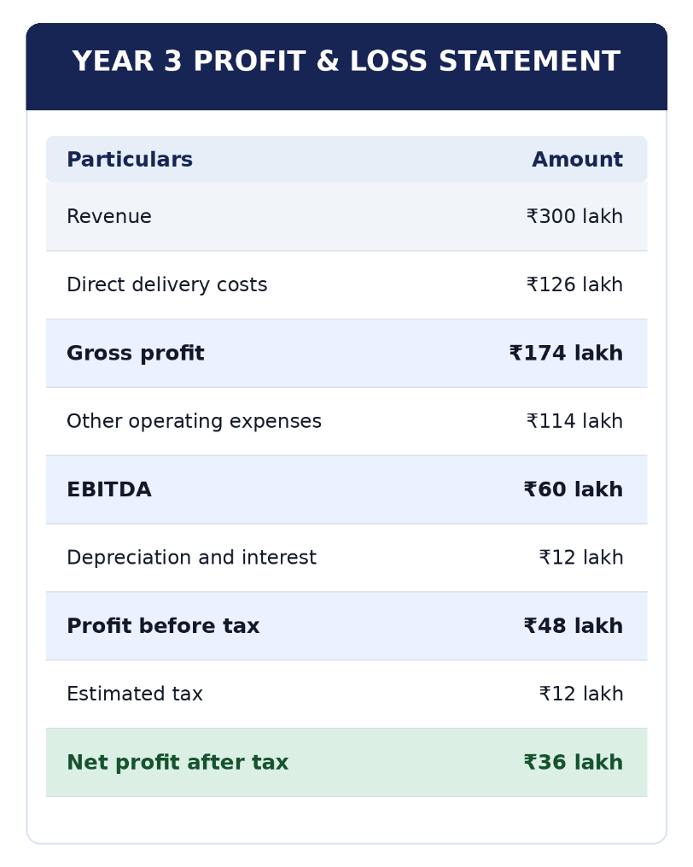
Key Financial Ratios
- Gross profit margin: 58%.
- EBITDA margin: 20%.
- Net profit margin: 12%.
Justification:
- Gross profit = ₹300 lakh − ₹126 lakh = ₹174 lakh.
- Gross margin = ₹174 lakh ÷ ₹300 lakh = 58%.
- EBITDA = ₹174 lakh − ₹114 lakh = ₹60 lakh.
- EBITDA margin = ₹60 lakh ÷ ₹300 lakh = 20%.
- Net margin = ₹36 lakh ÷ ₹300 lakh = 12%.
If asked why gross margin is 58%, explain that it is an assumed target for this model, not a verified industry benchmark. It must be supported by actual labour, subcontracting, cloud and delivery costs if presented as real performance.
Proposed Investment Requirement
Total Funding Required: ₹2 Crore
ANVEXA is seeking growth capital to expand its technology capabilities, acquire new clients, improve delivery capacity, and strengthen operational infrastructure.
Proposed Utilization of Funds
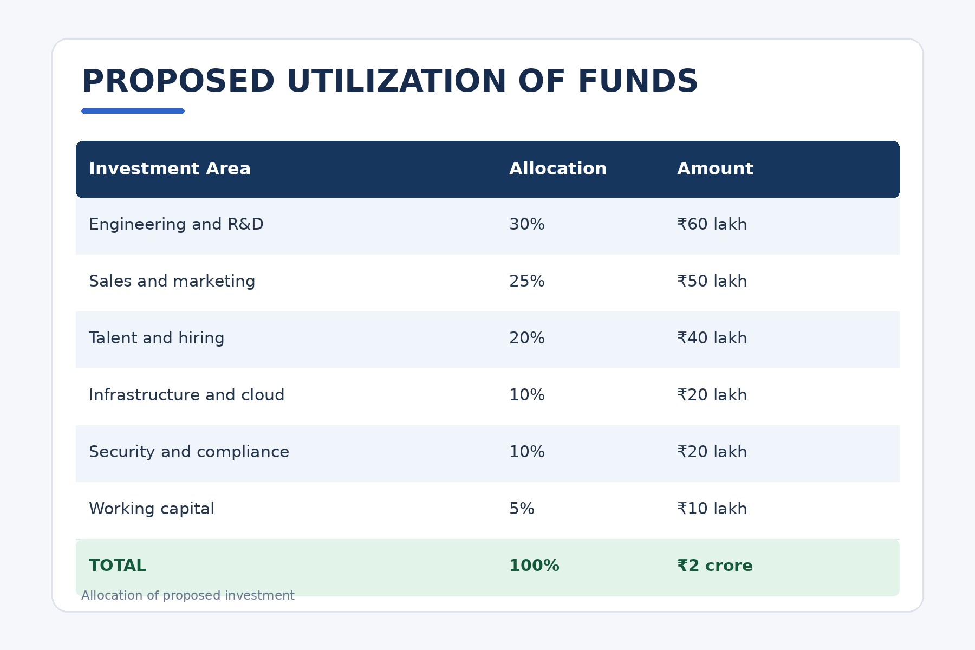
Financial discipline: Each allocation will have a defined objective, accountable owner, budget limit and measurable milestone.
Why allocate the money this way?
- ₹60 lakh for R&D: Productize repeatable solutions so they can be delivered more efficiently across clients.
- ₹50 lakh for sales and marketing: Develop a measurable B2B sales pipeline and acquire customers in the target regions.
- ₹40 lakh for hiring: Recruit technical and delivery staff against expected demand.
- ₹20 lakh for infrastructure: Support secure development, testing, cloud operations and service delivery.
- ₹20 lakh for security and compliance: Improve internal controls, security processes and audit readiness.
- ₹10 lakh for working capital: Provide a buffer for timing differences between client collections and business payments.

Valuation and investor benefits
Proposed Investment Terms
- Proposed investment: ₹2 crore.
- Proposed investor equity: 16.67%.
- Implied pre-money valuation: ₹10 crore.
- Implied post-money valuation: ₹12 crore.
Investor Value Proposition
- Participation in the company's future growth.
- Potential increase in equity value if the business grows successfully.
- Potential dividend income if dividends are declared and financially sustainable.
- Periodic financial reporting and visibility into the use of funds.
- Milestone-based capital deployment and financial risk monitoring.
Important: Returns are not guaranteed. Investment terms and valuation are subject to negotiation and due diligence.

Valuation justification:
If an investor contributes ₹2 crore for 16.67% ownership:
- Post-money valuation = ₹2 crore ÷ 16.67% ≈ ₹12 crore.
- Pre-money valuation = ₹12 crore − ₹2 crore = ₹10 crore.
The arithmetic is correct, but it does not prove the company is worth ₹10 crore before investment. For that, you need supporting evidence such as financial performance, recurring contracts, growth forecasts, risk, and comparable company valuations.

Cash flow and financial risk management
Protecting Financial Stability
Cash and Working Capital
- Illustrative cash and cash equivalents: ₹45 lakh.
- Illustrative outstanding client receivables: ₹35 lakh.
- Illustrative existing business loans: ₹20 lakh.
Financial Controls
- Maintain a rolling 13-week cash-flow forecast.
- Review overdue client invoices weekly.
- Use milestone-based billing where appropriate.
- Monitor project-level profitability and delivery costs.
- Link hiring and expansion to signed demand and delivery capacity.
- Review actual expenses against the approved budget every month.
Principal Financial Risks
- Delayed client payments.
- Dependence on a small number of clients.
- Project cost overruns and scope changes.
- Cybersecurity incidents and service disruption.
- Hiring costs growing faster than revenue.
Risk Mitigation
Use cash forecasting, customer diversification, clear contracts, approval controls and staged investment deployment.

Why this matters: A profitable company can still face cash shortages when clients pay late. Profit is an accounting measure; cash flow shows whether the company can actually pay salaries, vendors and other obligations.
The cash, receivables and loan figures are illustrative. Do not claim a specific cash runway until you have monthly cash-flow assumptions and committed expenses.
Our distinctive finance strategy
Capital with Purpose
ANVEXA's financial strategy is built on five principles:
- Milestone-Based Funding: Release and deploy capital against measurable progress.
- Three-Scenario Forecasting: Prepare optimistic, realistic and downside financial forecasts.
- Transparent Reporting: Provide regular updates on revenue, costs, cash flow and funding utilization.
- Profitability-Focused Growth: Prioritize services and clients that generate sustainable margins.
- Financial Accountability: Assign an owner, objective, budget and outcome to every major expense.
Our promise: We will not measure success by revenue alone. We will measure it by profitable growth, healthy cash flow, customer retention and responsible use of investor capital.
Three-year growth roadmap
Financial Growth Roadmap
Months 0–3
- Establish financial reporting and cash controls.
- Prioritize two repeatable product or service offerings.
- Validate project-level margins and recurring-contract economics.
Months 3–6
- Strengthen the Pune and Mumbai sales pipeline.
- Develop documented client case studies with permission.
- Track acquisition costs and payment collection periods.
Months 6–12
- Expand recurring service contracts.
- Monitor gross margin, customer retention and operating costs.
- Review performance against the approved budget.
Months 12–24
- Evaluate expansion into Gujarat and Bengaluru.
- Enter new markets only when demand, delivery capacity and unit economics support the decision.
Success Measures: Revenue growth, recurring revenue, gross margin, net profit, cash conversion, client retention and budget adherence.

Part 2: Investor questions you must be ready to answer
These are the questions most likely to be asked because they directly challenge the gaps in your earlier pitch.
A. Market reach and clients
Q1. Where exactly does ANVEXA operate?
Answer: “Our initial market focus is Pune and Mumbai. Gujarat and Bengaluru are potential expansion markets after we establish sufficient demand and delivery capacity. We are not claiming an established nationwide or global footprint.”
Why: It separates the current operating market from future ambition.
Q2. What type of clients do you have?
Answer: “Our target customer segments are SMEs and mid-market businesses in retail and distribution, IT and software services, logistics and manufacturing, and professional services. The client mix in this presentation is illustrative; actual client names and references would need to be substantiated.”
Q3. How can 32 clients generate ₹3 crore revenue?
Answer: “The model includes both recurring contracts and project revenue. The ₹90 lakh ARR represents annualized recurring contracts, while the remaining revenue must be explained through implementation, migration and custom development projects. We need a revenue breakdown by service to demonstrate the exact mix.”
This is a particularly important question. The figures are mathematically possible, but without a revenue bridge, the client count alone does not establish that the revenue is achievable.
B. Financial performance
Q4. Why is revenue growing from ₹1.2 crore to ₹3 crore?
Answer: “The model assumes growth from additional clients, larger projects and recurring support contracts. The growth rates are 66.7% in Year 2 and 50% in Year 3. These are planning assumptions, not independently verified results.”
Q5. Why is the net profit margin 12%?
Answer: “The Year 3 model assumes ₹3 crore revenue and ₹36 lakh net profit. The net profit margin is ₹36 lakh divided by ₹300 lakh, which equals 12%. We would need actual cost records to establish whether that margin is achievable.”
Q6. Your draft says cumulative revenue is ₹2.85 crore. Why are you now saying ₹6.2 crore?
Answer: “The three annual revenue figures previously used—₹1.2 crore, ₹2 crore and ₹3 crore—add up to ₹6.2 crore. The earlier cumulative figure is inconsistent with those annual numbers. We have used ₹6.2 crore in this proposed model, but it must be verified against the intended company data.”
Q7. Was Year 1 profitable or loss-making?
Answer: “The earlier draft contains contradictory statements. The current model uses ₹6 lakh net profit in Year 1. If Year 1 was intended to be loss-making, the financial model must be revised rather than presenting both versions.”
C. Funding and valuation
Q8. Why do you need ₹2 crore?
Answer: “The proposed funding supports R&D, customer acquisition, hiring, infrastructure, security and working capital. Each allocation is linked to a specific business purpose, and the company should monitor actual expenditure against approved budgets and milestones.”
Q9. How did you decide the company is worth ₹10 crore before investment?
Answer: “The ₹10 crore pre-money valuation is a proposed negotiation assumption, not an independent valuation. The ₹2 crore investment for 16.67% ownership implies a ₹12 crore post-money valuation and ₹10 crore pre-money valuation. The proposed valuation would need to be tested against revenue quality, profitability, recurring contracts, growth prospects and risks.”
Q10. What guaranteed return will investors receive?
Answer: “We cannot guarantee investment returns. Investors may benefit from equity appreciation, a future share sale or dividends if declared and financially sustainable. Actual returns depend on business performance, dilution, market conditions and exit opportunities.”
D. Cash flow and financial controls
Q11. If your company is profitable, why do you need external funding?
Answer: “Profitability does not necessarily mean the company has enough cash to fund expansion. Client payments may arrive after salaries, vendor costs and other expenses are due. The funding request is intended to support planned growth, while cash forecasting and working-capital controls help manage liquidity.”
Q12. What happens if revenue is lower than expected?
Answer: “We would update our forecast, slow discretionary hiring, prioritize higher-margin services, defer expansion and monitor cash more closely. The downside plan should be prepared before committing the entire investment.”
Q13. How will you ensure investor money is not wasted?
Answer: “We propose a board-approved budget, approval limits, documented procurement, milestone-based deployment and monthly reporting. Each major allocation should have an owner, a target and a way to measure progress.”
Q14. How will you know if the investment is successful?
Answer: “We will monitor revenue growth, ARR, gross margin, net profit, customer retention, receivables, cash flow and delivery against funding milestones. We will report actual performance against our forecast and explain any material variance.”
Part 3: Your CFO calculation sheet
Memorize these formulas. They allow you to answer follow-up questions without relying on prepared sentences.
Metric | Formula
Revenue growth | (Current revenue − Previous revenue) ÷ Previous revenue × 100
Gross profit | Revenue − Direct delivery costs
Gross margin | Gross profit ÷ Revenue × 100
EBITDA | Gross profit − Other operating expenses, before depreciation, interest and tax
Net profit margin | Net profit after tax ÷ Revenue × 100
ARR | Annualized value of active recurring contracts
Post-money valuation | Investment ÷ Investor ownership percentage
Pre-money valuation | Post-money valuation − New investment
Client concentration | Largest client's revenue ÷ Total revenue × 100

